Paper 1 – Section B

You are going to enter a creative writing competition.
Your entry will be judged by a panel of people of your own age.

Either: Write a description suggested by this picture:

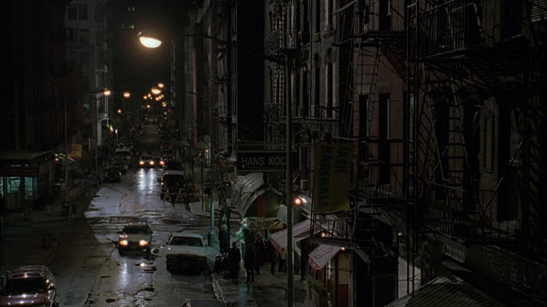

Or: Write the opening part of a story about a secret journey taken at night.

(24 marks for content and organisation 16 marks for technical accuracy)
[40 marks]

Outline script for Describe a city at night (can use with the image)
Imagine you are standing in a dimly lit hallway. You step out through the green painted door in front of you. You are in a darkened side street lit only by a single lamppost. Look at the lamppost and the kind of glow it creates. Look at its reflection on the street. What is the texture that you see? What is the pavement made of? What colour is the glow from the street lamp?
* You cross the road under the glow of the lamp and as you walk along the street, the buildings loom out of the darkness on your left hand side. What is the building on your left? How tall? How many floors? What type of building?
* There is a fire escape on this building, made of wrought iron and spiralling up to the top floor. It seems to be black-painted, though you can’t quite tell in this gloomy street. What you can see is that there is something caught on this fire escape, towards the top. What can you see that is caught on the fire escape?
* You move along this street now and there is a second building. It is four floors tall and filled with windows in total darkness. What kind of building is it? Flats? A factory? Offices closed up for the night? An old warehouse? However, you notice a solitary light in one window on one of its upper floors. Look at that window? What do you see in the window?
* As you move to the end of the street you notice a change in the weather. What was it like when you set out? You are pulling your coat around you now. Why? Note down the change in the weather.
* You are turning out of the side street now into a much more brightly lit area – more in the centre of the city. As you move into this area, there are buildings with plate glass windows all around you. What are those buildings? Take notice of what they are. Shops? Offices maybe? Focus in on one of those plate glass windows. Write down what you see.
* The night has been quiet so far, still and silent, but suddenly a noise pierces the darkness. What is that noise?

This technique works well with any location: try a beach, a railway station, a shopping centre. It also works well as a way of describing people or characters: try it for a person your students know well or for a character from a play, where they have to visualise how they might look, their mannerisms, the sound of their voice, as well as think about their personality.

